Name: | Debjit Ghosal
UID: | 2023300065
Experiment No. | 5

AIM: | Program on Inheritance
Program 1
PROBLEM STATEMENT : | The cost of stock on each day is given in an array A[] of size N. Day 1 price in first location, day 2 price in  second location etc. Find all the days on which you buy and sell the stock any number of times so that in  between those days your profit is maximum.A new transaction can only start after the previous  transaction is complete. Person can hold only one share at a time. Create a class Stock that has the name  of stock and array of prices. Also it has input method that initialises the predicted price of the stock in an  array of length N. Create class Transaction that is a sub class of Stock class. It has method  findMaximumProfit method.  Example Stock Prices: {1, 5, 2, 3, 7, 6, 4, 5}  Total profit earned is 10  Buy on day 1 and sell on day 2  Buy on day 3 and sell on day 5  Buy on day 7 and sell on day 8
PROGRAM: | import java.util.*;  class Stock {  String name;  int[] prices;  public Stock(String name, int[] prices) {  this.name = name;  this.prices = prices;  }  }  class Transaction extends Stock {  public Transaction(String name, int[] prices) {  super(name, prices);  }  public void findMaximumProfit() {  int maxProfit = 0;  List<Integer> buyDays = new ArrayList<>();  List<Integer> sellDays = new ArrayList<>();  int buyDay = 0;  int sellDay = 0;  for (int i = 0; i < prices.length - 1; i++) {  if (prices[i + 1] > prices[i]) {  buyDays.add(i);  buyDay = i;  while (i < prices.length - 1 && prices[i + 1] >= prices[i]) {  i++;  }  sellDays.add(i);  sellDay = i;  maxProfit += prices[sellDay] - prices[buyDay];  }  }  System.out.println("Total profit earned is " + maxProfit);  for (int i = 0; i < buyDays.size(); i++) {  System.out.println("Buy on day " + (buyDays.get(i) + 1) + " and sell on day " + (sellDays.get(i) + 1));  }  }  }  public class Stock1 {  public static void main(String[] args) {  Scanner scanner = new Scanner(System.in);  System.out.print("Enter the name of the stock: ");  String stockName = scanner.nextLine();  System.out.print("Enter number of days: ");  int n = scanner.nextInt();  int[] prices = new int[n];  for (int i = 0; i < n; i++) {  System.out.print("Enter price for day " + (i + 1) + ": ");  prices[i] = scanner.nextInt();  }  Transaction transaction = new Transaction(stockName, prices);  transaction.findMaximumProfit();  }  }
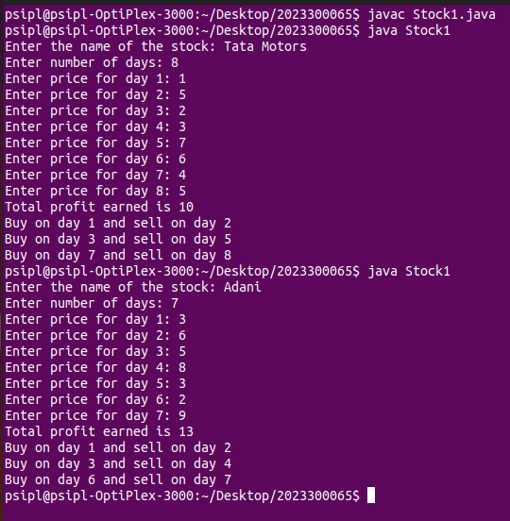
RESULT:

Program 2
PROBLEM STATEMENT : | Define parent class "Employee" that has 3 private attributes  String name, String id, int age.  Employee has constructor with 3 arguments that set value of name, id, age. It also has getter and setter  methods for all 3 private attributes.  Class "SalariedEmployee" is a sub class of Employee and has 1 private attribute empSalary.  "SalariedEmployee" can be permanent or on contract and has constructor SalariedEmployee(String name,  String id, int age, double empSalary) to set the values.  constructor SalariedEmployee must call the superclass constructor to set name, id, age and call setter  method to set the salary.  Employee salary is empSalary + 2000(allowance) if he is a permanent employee else Employee salary is  empSalary (no allowance).  Accept the details of 5 employees and print details of the employee with highest salary.  Create class Tester with main method
PROGRAM: | import java.util.Scanner;  class Employee {  private String name;  private String id;  private int age;  public Employee(String name, String id, int age) {  this.name = name;  this.id = id;  this.age = age;  }  // Getters and setters  public String getName() {  return name;  }  public void setName(String name) {  this.name = name;  }  public String getId() {  return id;  }  public void setId(String id) {  this.id = id;  }  public int getAge() {  return age;  }  public void setAge(int age) {  this.age = age;  }  }  class SalariedEmployee extends Employee {  private double empSalary;  public SalariedEmployee(String name, String id, int age, double empSalary) {  super(name, id, age);  this.empSalary = empSalary;  }  public double getEmpSalary() {  return empSalary;  }  public void setEmpSalary(double empSalary) {  this.empSalary = empSalary;  }  // Calculate salary with allowance for permanent employees  public double calculateSalary() {  return (this instanceof PermanentEmployee) ? empSalary + 2000 : empSalary;  }  }  class PermanentEmployee extends SalariedEmployee {  public PermanentEmployee(String name, String id, int age, double empSalary) {  super(name, id, age, empSalary);  }  }  class ContractEmployee extends SalariedEmployee {  public ContractEmployee(String name, String id, int age, double empSalary) {  super(name, id, age, empSalary);  }  }  public class Tester {  public static void main(String[] args) {  Scanner scanner = new Scanner(System.in);  SalariedEmployee[] employees = new SalariedEmployee[5];  for (int i = 0; i < 5; i++) {  System.out.println("Enter details for employee " + (i + 1));  System.out.print("Name: ");  String name = scanner.nextLine();  System.out.print("ID: ");  String id = scanner.nextLine();  System.out.print("Age: ");  int age = scanner.nextInt();  System.out.print("Salary: ");  double salary = scanner.nextDouble();  scanner.nextLine(); // Consume newline  System.out.print("Is the employee permanent? (yes/no): ");  String permanent = scanner.nextLine().toLowerCase();  if (permanent.equals("yes")) {  employees[i] = new PermanentEmployee(name, id, age, salary);  } else {  employees[i] = new ContractEmployee(name, id, age, salary);  }  }  // Finding employee with highest salary  SalariedEmployee highestPaidEmployee = employees[0];  for (int i = 1; i < employees.length; i++) {  if (employees[i].calculateSalary() > highestPaidEmployee.calculateSalary()) {  highestPaidEmployee = employees[i];  }  }  System.out.println(" ");  System.out.println("Employee with highest salary:");  System.out.println("Name: " + highestPaidEmployee.getName());  System.out.println("ID: " + highestPaidEmployee.getId());  System.out.println("Age: " + highestPaidEmployee.getAge());  System.out.println("Salary: " + highestPaidEmployee.calculateSalary());  }  }
RESULT:
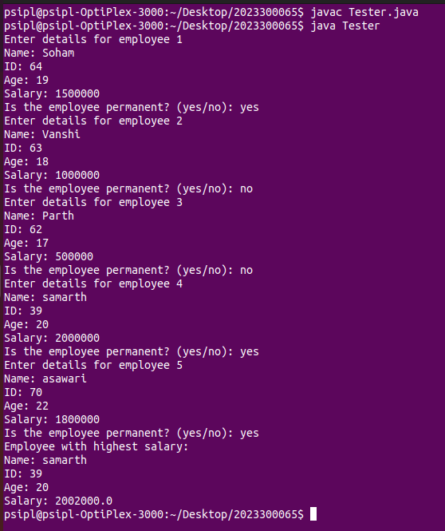

CONCLUSION: | I have learnt about inheritance.I have learnt how to use extend parent class properties to child class. I have also learnt that we need to use super keyword for calling a parametrized default class.

